Hood Latch and Wiper Motor-Arm
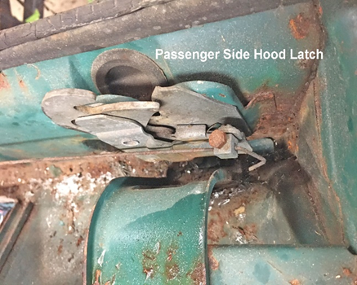passenger side hood latch | 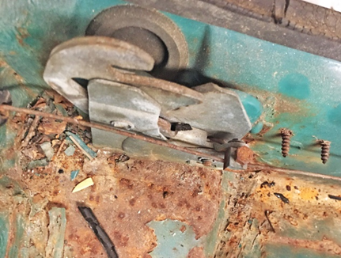driver side hood latch
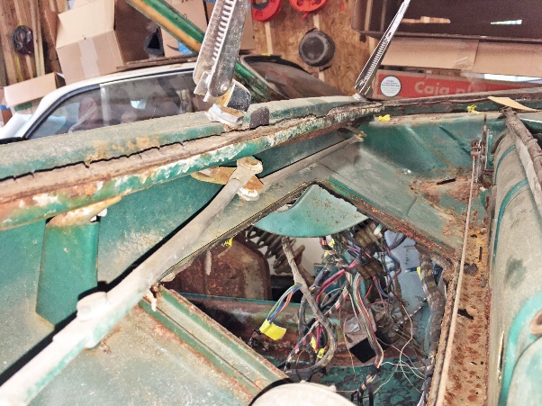  Wiper arms | 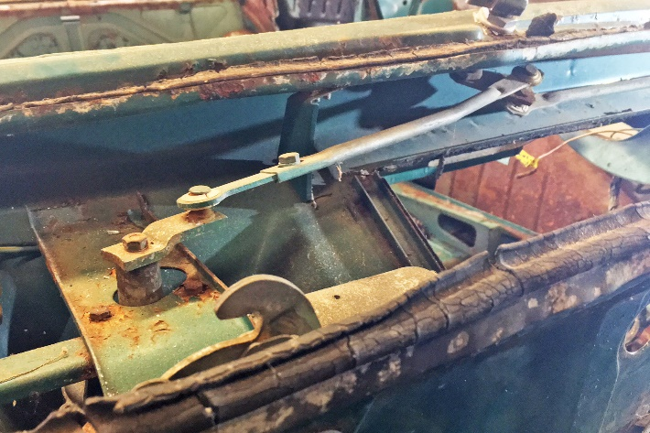wiper arm attached to motor
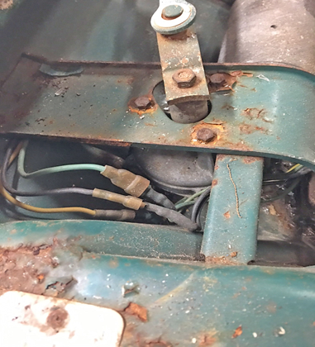
Wiper motor note yellow, black and green wire arrangement

